**Supplementary Figure Legends:**

Suppl. Figure 1: Maxima for surface temperature (°C) and for 1-day precipitation (mm), based on 2008 simulation.

Suppl. Figure 2: Comparison of 2008 and 1990 simulations: Mean surface temperature in °C at the K/P boundary based on (a) 1990 and (b) 2008 simulation. Mean daily precipitation in mm at the K/P boundary based on (c) 1990 and (d) 2008 simulation.

Suppl. Figure 3: Madagascar’s modern topography. The contour interval is 500 m for the height field.

**Supplementary Table Legends:**

Suppl. Table 1: Vertebrate fossil taxa represented in Late Cretaceous deposits (Maevarano Formation).

Suppl. Table 2: Vertebrate clades inferred to be present in Madagascar during the Early Paleogene.\*

**Supplementary Figure 1**

**MACHDD:Users:karensamonds:Documents:Manuscripts:2015:Past Climate:Figsup1_maxNEW.pdf**

**MACHDD:Users:karensamonds:Documents:Manuscripts:2015:Past Climate:Figsup2a_comp_1990vs2008_pre_creNEW.pdfSupplementary Figure 2**

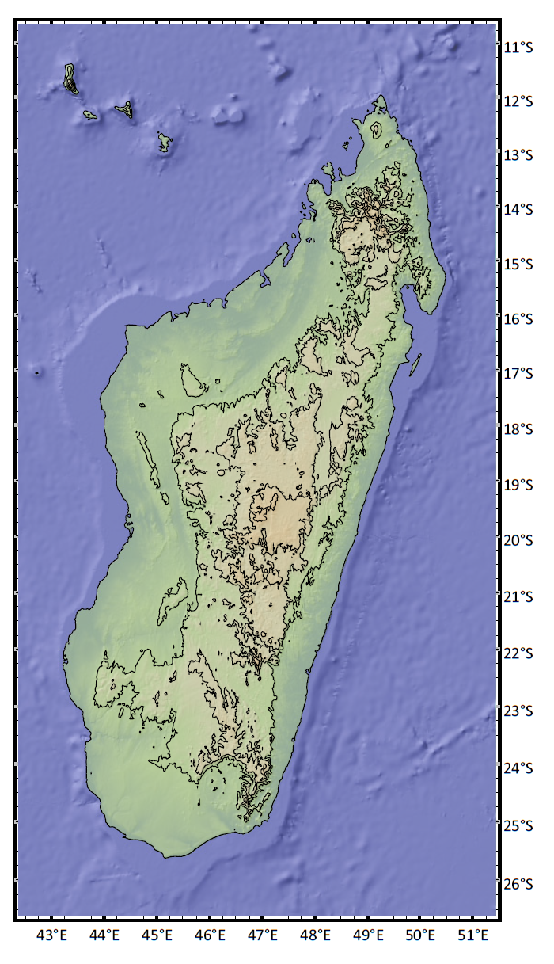**Supplementary Figure 3**

**Table S1:**

|  |  |  |  |
| --- | --- | --- | --- |
| **Taxon** | **Malagasy Genera** | **Class** | **References** |
| Lepisosteidae | *Lepisosteus* | Osteichthyes | (1) |
| Phyllodontidae | cf. *Egertonia* sp. | Osteichthyes | (1) |
| Pycnodontidae | cf. *Coelodus* sp. | Osteichthyes | (2) |
| Ceratophryinae | *Beelzebufo* | Amphibia | (3) |
| Bothremydidae | *Kinkonychelys* | Reptilia | (4) |
| Podocnemidae | *Erymnochelys,* | Reptilia | (5) |
| Podocnemidae | *Sokatra* | Reptilia | (6) |
| Mahajangasuchidae | *Mahajangasuchus* | Reptilia | (7, 8) |
| Notosuchia | *Araripesuchus* | Reptilia | (9) |
| Notosuchia | *Simosuchus* | Reptilia | (10, 11) |
| Trematochampsidae | *Miadanasuchus* | Reptilia | (12) |
| ?Cordylidae | *Konkasaurus* | Reptilia | (13) |
| Dromaeosauridae | *Rahonavis* | Reptilia | (14, 15) |
| Madtsoiidae | *Madtsoia* | Reptilia | (16) |
| Madtsoiidae | *Menarana* | Reptilia | (17) |
| Nigerophiidae | *Kelyophis* | Reptilia | (17) |
| Abelisauridae | *Majungasaurus* | Reptilia | (18) |
| Noasauridae | *Masiakasaurus* | Reptilia | (19) |
| Nemegtosauridae | *Rapetosaurus* | Reptilia | (20) |
| Ornithurae | *Vorona* | Aves | (21) |
| Marsupialia | Genus indet. | Mammalia | (22) |
| Multituberculata | Genus indet. | Mammalia | (23) |
| Sudamericidae | *Lavanify* | Mammalia | (24) |

**Table S2:**

|  |  |  |  |  |  |  |
| --- | --- | --- | --- | --- | --- | --- |
| **Family** | **Descendant Genera** | **Class** | **Humid (including degraded)** | **Dry (mostly west and northwest including degraded)** | **Spiny (including degraded)** | **References / notes** |
| Aplocheilidae | *Pachypanchax* | Osteichthyes | 1 | 1 | 0 | (25) |
| Bedotiidae | *Bedotia*, *Rheocles* | Osteichthyes | 1 | 0 | 0 | (26) |
| Cichlidae | *Oxylapia, Paratilapia, Paretroplus, Ptychochromis, Ptychochromoides* | Osteichthyes | 1 | 1 | 1 | (27, 28) |
| Clupeidae | *Sauvagella, Spratellomorpha* | Osteichthyes | 1 | 1 | 0 | (29) |
| Milyeringidae | *Typhleotris* | Osteichthyes | 0 | 0 | 1 | (30) |
| Mugilidae | *Agonostomus, Liza, Mugil* | Osteichthyes | 1 | 1 | 1 | (31) |
| Microhylidae | Cophylinae + Scaphiophryninae | Amphibia | 1 | 1 | 1 | (32) |
| Microhylidae | Dyscophinae | Amphibia | 1 | 1 | 1 | (32) |
| Mantellidae | *Aglyptodactylus*, *Blommersia*, *Boehmantis*, *Boophis*, *Gephyromantis*, *Guibemantis*, *Laliostoma*, *Mantella*, *Mantidactylus*, *Spinomantis*, *Tsingymantis*, *Wakea* | Amphibia | 1 | 1 | 1 | (32)There is only one mantellid species in the SW: *Laliostoma labrosum*. |
| Chamaeleonidae | *Brookesia*, *Calumma*, *Furcifer* | Reptilia | 1 | 1 | 1 | (32) |
| Gerrhosauridae | *Zonosaurus, Tracheloptychus* | Reptilia | 1 | 1 | 1 | (33, 34) |
| Opluridae | *Chalarodon, Oplurus* | Reptilia | 1 | 1 | 1 | (34) |
| Gekkonidae | *Blaesodactylus, Lygodactylus, Phelsuma, Paroedura, Uroplatus* | Reptilia | 1 | 1 | 1 | (32) |
| Scincidae | *Amphiglossus, Androngo, Madascincus, Paracontias, Pseudoacontias, Pygomeles, Sirenoscincus, Voeltzkowia* | Reptilia | 1 | 1 | 1 | (32) |
| Boidae | *Acrantophis*, *Sanzinia*, *Calabaria* | Reptilia | 1 | 1 | 1 | (32) |
| Typhlopidae (Madatyphopidae) | *Typhlops (Madatyphlops)* | Reptilia | 1 | 1 | 1 | (32) |
| Xenotyphlopidae | *Xenotyphlops* | Reptilia | 0 | 1 | 0 | (32) |
| Aepyornithidae | *Aepyornis, Mullerornis* | Aves |  | 1 | 1 | (35) Known from Quaternary deposits only, so no knowledge of east. |
| Eurylaimidae | *Neodrepanis, Philepitta* | Aves | 1 | 1 | 0 | (36) |
| Mesitornithidae | *Mesitornis, Monias* | Aves | 1 | 1 | 1 | (36) |
| Psittacidae | *Agapornis* | Aves | 1 | 1 | 1 | (36) |
| Psittacidae | *Coracopsis* | Aves | 1 | 1 | 1 | (36) |
| Bibymalagasia | *Plesiorycteropus* | Mammalia |  | 1 | 1 | (37, 38) Known from Quaternary deposits only, so no knowledge of east. |
| Lemuroidea and Daubentonioidea | *Allocebus*, *Avahi*, *Cheirogaleus*, *Daubentonia*, *Eulemur*, *Hapalemur*, *Indri*, *Lemur*, *Lepilemur*, *Microcebus*, *Mirza, Phaner*, *Prolemur*, *Propithecus, Varecia* | Mammalia | 1 | 1 | 1 | (39) |

\*0 = absent, 1 = present, blank = unknown.

**References for Tables S1 and S2**

1. Gottfried M & Krause D (1998) First record of gars (Lepisosteidae, Actinopterygii) on Madagascar: Late Cretaceous remains from the Mahajanga Basin. *Journal of Vertebrate Paleontology* 18(2):275-279.

2. Rogers RR, Hartman JH, & Krause DW (2000) Stratigraphic analysis of Upper Cretaceous rocks in the Mahajanga Basin, northwestern Madagascar: Implications for ancient and modern faunas. *The Journal of Geology* 108:275-301.

3. Evans SE, Jones MEH, & Krause DW (2008) A giant frog with South American affinities from the Late Cretaceous of Madagascar. *Proc. Natl. Acad. Sci. U. S. A.* 105(8):2951-2956.

4. Gaffney E, Krause D, & Zalmout I (2009) *Kinkonychelys*, a new side-necked turtle (Pelomedusoides: Bothremydidae) from the Late Cretaceous of Madagascar. *American Museum Novitates* 3662:1-25.

5. Gaffney E & Forster C (2003) Side-necked turtle lower jaws (Podocnemididae, Bothremydidae) from the Late Cretaceous Maevarano Formation of Madagascar. *American Museum Novitates* (3397):1-13.

6. Gafffney E & Krause D (2011) *Sokatra*, a new side-necked turtle (Late Cretaceous, Madagascar) and the diversification of the main groups of Pelomedusoides. *American Museum Novitates* 3728:1-28.

7. Buckley GA & Brochu CA (1999) An enigmatic new crocodile from the Upper Cretaceous of Madagascar. *Cretaceous Fossil Vertebrates*, ed Unwin D (Paleontological Association Special Papers in Paleontology), Vol 60, pp 149-175.

8. Turner A & Buckley G (2008) *Mahajangasuchus insignis* (Crocodyliformes: Mesoeucrocodylia) cranial anatomy and new data on the origin of the eusuchian-style palate. *Journal of Vertebrate Paleontology* 28:382-408.

9. Turner A (2006) Osteology and phylogeny of a new species of *Araripesuchus* (Crocodyliformes: Mesoeucrocodylia) from the Late Cretaceous of Madagascar. *Historical Biology* 18:255-369.

10. Buckley G, Brochu C, Krause D, & Pol D (2000) A pug-nosed crocodyliform from the Late Cretaceous of Madagascar. *Nature* 405:941-944.

11. Turner A & Sertich J (2010) Phylogenetic history of Simosuchus clarki (Crocodyliformes: Notosuchia) from the Late Cretaceous of Madagascar. *Journal of Vertebrate Paleontology* 30:177-236.

12. Rasmusson Simons E & Buckley G (2009) New material of "Trematochampsa" oblita (Crocodyliformes,Trematochampsidae) from the Late Cretaceous of Madagascar. *Journal of Vertebrate Paleontology* 29:599-604.

13. Krause D, Evans S, & Gao K-Q (2003) First definitive record of Mesozoic lizards from Madagascar. *Journal of Vertebrate Paleontology* 23:842-856.

14. Forster C (1999) Gondwanan dinosaur evolution and biogeographic analysis. *Journal of African Earth Sciences* 28(1):169-185.

15. Makovicky P, Apestegula S, & Agnolín F (2005) The earliest droeaeosaurid theropod from South America. *Nature* 437:1007-1011.

16. Hoffstetter R (1961) Nouveaux restes d'un serpent boïdé (*Madtsoia madagascariensis* nov. sp.) dans le Crétacé supérieur de Madagascar. *Bulletin du Muséum national d'Histoire naturelle, Paris* 33:152-160.

17. LaDuke T, Krause D, Scanlon J, & Kley N (2010) A Late Cretaceous (Maastrichtian) snake assemblage from the Maevarano Formation, Mahajanga Basin, Madagascar. *Journal of Vertebrate Paleontology* 30:109-138.

18. Krause D, Sampson S, Carrano M, & O'Connor P (2007) Overview of the history of discovery, taxonomy, phylogeny, and biogeography of *Majungasaurus crenatissimus* (Theropoda: Abelisauridae) from the Late Cretaceous of Madagascar. *Majungasaurus crenatissimus (Theropoda: Abelisauridae) from the Late Cretaceous of Madagascar: Society of Vertebrate Paleontology Memoir*, eds Sampson S & Krause D), pp 1-20.

19. Sampson S, Carrano M, & Forster C (2001) A bizarre predatory dinosaur from the Late Cretaceous of Madagascar. *Nature* 409:504-506.

20. Curry-Rogers K & Forster C (2001) The last of the dinosaur titans: a new sauropod from Madagascar. *Nature* 412:530-534.

21. Forster C, Chiappe L, Krause D, & Sampson S (1996) The first Cretaceous bird from Madagascar. *Nature* 382(8 August 1996):532-534.

22. Krause D (2001) Fossil molar from a Madagascan marsupial. *Nature* 412(2 August):497-498.

23. Krause DW*, et al.* (2006) Late Cretaceous terrestrial vertebrates from Madagascar: Implications for Latin American biogeography. (Missouri Botanical Garden), pp 178-208.

24. Krause DW (1997) Cosmopolitanism among Gondwanan Late Cretaceous mammals. *Nature* 390(4 December):504-507.

25. Loiselle P (2006) A review of the Malagasy *Pachypanchax* (Teleostei: Cyprinodontiformes, Aplocheilidae) with descriptions of four new species. *Zootaxa* 1366:1-44.

26. Stiassny M (1990) Notes on the anatomy and relationships of the Bedotiid fishes of Madagascar, with a taxonomic revision of the genus *Rheocles* (Atherinomorpha: Bedotiidae). *American Museum Novitates* 2979:1-33.

27. Sparks J & Schaefer S (2002) *Ptychochromis inornatus*: A new cichlid (Teleostei: Cichlidae) from northwestern Madagascar, with a discussion of intrageneric variation in *Ptychochromis*. *Copeia* 2002(1):120-130.

28. Stiassny MLJ (1991) Phylogenetic intrarelationships of the family Cichlidae: an overview. *Cichlid Fishes: behaviour, ecology and evolution*:1 - 35.

29. Stiassny MLJ (2002) Revision of Sauvagella Bertin (Clupeidae; Pellonulinae; Ehiravini) with a description of a new species from the freshwaters of Madagascar and diagnosis of the Ehiravini. *Copeia* (1):67-76.

30. Sparks J & Chakrabarty P (2012) Revision of the endemic Malagasy cavefish genus *Typhleotris* (Teleostei, Gobiiformes, Milyeringidae), with discussion of its phylogenetic placement and description of a new species. *American Museum Novitates* 3764:1-28.

31. Fischer W & Bianchi G eds (1984) *FAO species identification sheets for fishery purposes. Western Indian Ocean (Fishing Area 51)* (Danish International Development Agency (DANIDA). Rome, Food and Agriculture Organization of the United Nations, Denmark), Vol 3: Bony fishes: Families Lutjanidae to Scaridae.

32. Brown J, Cameron A, Yoder A, & Vences M (2014) A necessarily complex model to explain the biogepography of the amphibians and reptiles of Madagascar. *Nature Communications* 5(5046):1-10.

33. Blair C*, et al.* (2015) Multilocus phylogenetic and geospatial analyses illuminate diversification patterns and the biogeographic history of Malagasy endemic plated lizards (Gerrhosauridae: Zonosaurinae). *Journal of Evolutionary Biology* 28(2):481-492.

34. Raselimanana A & Goodman S (2013) Lizards or the Class Reptilia. *Atlas of selected land vertebrates of Madagascar*, eds Goodman S & Raherilalao M (Association Vahatra, Antananarivo, Madagascar), pp 35-62.

35. Goodman SM & Rakotozafy LMA (1997) Subfossil birds from coastal sites in western and southwestern Madagascar, a paleoenvironmental reconstruction. *Natural Change and Human Impact in Madagascar*, eds Goodman S & Patterson B (Smithsonian Institution Press, Washington D. C.), pp 257-279.

36. Goodman S & Raherilialao M (2013) Birds or the Class Aves. *Atlas of selected land vertebrates of Madagascar*, eds Goodman S & Raherilalao M (Association Vahatra, Antananarivo, Madagascar), pp 63-168.

37. MacPhee RDE (1994) Morphology, adaptations, and relationships of *Plesiorycteropus*, and a diagnosis of a new order of eutherian mammals. *Bulletin of the American Museum of Natural History* 220:1-214.

38. Burney DA*, et al.* (2004) A chronology for late prehistoric Madagascar. *Journal of Human Evolution* 47:25-63.

39. Mittermeier R*, et al.* (2010) *Lemurs of Madagascar Tropical Field Guide* (Conservational International, US, Arlington, VA) 3rd Ed.